CE 4510/5543 Foundation Design
Spring 2021
Course Modality
- Hybrid/Blended (HB) - These classes have both in-person and online components. Classes will not meet in person for all scheduled meetings, but some in-person instruction will occur. At least 25% of mandatory instruction for the class will occur in person.

- All submissions and grades of homework assignments and the mid-term and final exams are handled online through huskyct. No paper submission is allowed.

In-person Section:
CE4510-001 & CE 5543-001 (In-Person): An in-person class meet Feb. 2nd (Tuesday) and every other Thursday and on April 8th. Students are encouraged to watch video lectures in huskyct for all other sessions.
In-person Class Dates: Feb. 2nd, Feb. 18th, March 4th, March 18th, April 1st, April 8th
In-person Class Hours: 12:30-1:45PM
Class Room: SU 101
Class videos and materials are available at huskyct

Online Section:
CE4510-001X: fully online
Class videos and materials are available for all sessions at huskyct

Instructor:
Jeongho Kim, Associate Professor, Civil and Environmental Engineering
Email: Jeongho.kim@uconn.edu, Cell: 860-428-2724
Office hours: Online meeting through webex or call

Graduate Teaching Assistant: Zheng Ren, zheng.3.ren@uconn.edu
Office hours: Wednesday 11:00AM-12:30PM (online meeting through webex)
Here is my webex link: https://uconn-cmr.webex.com/meet/zhr19002
Textbook:
Principles of Foundation Engineering, 9th Edition, Braja M. Das
ISBN-10: 133770503 and ISBN-13: 9781337705035
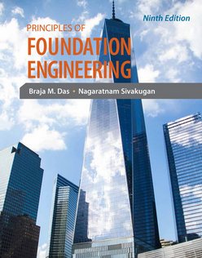

Course Objectives: (will cover Chapters 2, 6, 7, 8, 9, 10, 11, 12, 16)
By the end of the semester, students will be able to:
- Select and design proper foundation for various structures on variable types of soils.
- Calculate the capacity of shallow foundation
- Calculate settlement in shallow foundation
- Design mat foundation
- Understand the mechanism for pile foundations, their capacities, and design
- Design retaining walls
Student Authentication and Verification
The University of Connecticut is required to verify the identity of students who participate in distance learning or online courses and to establish that students who register in these courses are the same students who participate in and complete the course activities and assessments and receive academic credit. Verification and authentication of student identity in this course will include the following two methods.

Method 1: We will use HuskyCT as the primary repository and access point for course content, assessment, and activities, and students use their NetID and password process to securely access course content/ assessments.

Method 2: We will use Respondus Lockdown Browser with Monitor to record student display of ID in exam sessions. We will be administering mid-term exam remotely by using Lockdown Browser with Respondus monitor during online examinations to help promote academic integrity. In Week 1, follow the instruction in the end of this syllabus to install the software. A pilot exam is given in the huskyct for you to test the installed software. This will allow you an opportunity to test the technology and identify any potential complications that may arise during the mid-term and final exams.
Homework:
- To receive full credit on your homework, you must:
- Write neatly;
- Note any given values and the value you seek to calculate;
- Write your solution including all equations and calculation procedures;
- Circle or box your final answer;
- Submit at huskyct in either single PDF or WORD (with scanned image files inserted) format.
- All homework will be posted to HuskyCT in time during the semester. The due date is mentioned on each assignment. Homework solutions will be posted.

- I will notify you through the HuskyCT after I post HW or HW solutions. Please check your emails frequently.

- Feedback on HW will be provided about in 1 week.
Calculators:
You can use any types of calculator during the class and during the exam.
Your final grade:
Homework (online submission) | 20%
Midterm exam (online) | 40%
Final Exam (online) | 40%

Important Dates:
- Midterm Exam: Date and Time Windows TBD (1 hour and 30 minutes online exam)
- Final Exam: Date and Times TBD (2 hour and 15 minutes online exam)
Grading Scale: (May be subject to change)

Grade | Letter Grade | GPA
93-100 | A | 4.0
90-92 | A- | 3.7
87-89 | B+ | 3.3
83-86 | B | 3.0
80-82 | B- | 2.7
77-79 | C+ | 2.3
73-76 | C | 2.0
70-72 | C- | 1.7
67-69 | D+ | 1.3
63-66 | D | 1.0
60-62 | D- | 0.7
<60 | F | 0.0

Student Responsibilities and Resources
As a member of the University of Connecticut student community, you are held to certain standards and academic policies. In addition, there are numerous resources available to help you succeed in your academic work. This section provides a brief overview to important standards, policies and resources.
Student Code
You are responsible for acting in accordance with the University of Connecticut's Student Code Review and become familiar with these expectations. In particular, make sure you have read the section that applies to you on Academic Integrity:
- Academic Integrity in Undergraduate Education and Research
- Academic Integrity in Graduate Education and Research
Cheating and plagiarism are taken very seriously at the University of Connecticut. As a student, it is your responsibility to avoid plagiarism. If you need more information about the subject of plagiarism, use the following resources:
- Plagiarism: How to Recognize it and How to Avoid It
- Instructional Module about Plagiarism
- University of Connecticut Libraries’ Student Instruction (includes research, citing and writing resources)

Copyright

Copyrighted materials within the course are only for the use of students enrolled in the course for purposes associated with this course and may not be retained or further disseminated.

Netiquette and Communication

At all times, course communication with fellow students and the instructor are to be professional and courteous. It is expected that you proofread all your written communication, including discussion posts, assignment submissions, and mail messages. If you are new to online learning or need a netiquette refresher, please look at this guide titled, The Core Rules of Netiquette.
Adding or Dropping a Course
If you should decide to add or drop a course, there are official procedures to follow:
- Matriculated students should add or drop a course through the Student Administration System.
- Non-degree students should refer to Non-Degree Add/Drop Information located on the registrar’s website.
You must officially drop a course to avoid receiving an "F" on your permanent transcript. Simply discontinuing class or informing the instructor you want to drop does not constitute an official drop of the course. For more information, refer to the:
- Undergraduate Catalog
- Graduate Catalog

Academic Calendar
The University's Academic Calendar contains important semester dates.
Academic Support Resources
Technology and Academic Help provides a guide to technical and academic assistance.
Students with Disabilities
Students needing special accommodations should work with the University's Center for Students with Disabilities (CSD). You may contact CSD by calling (860) 486-2020 or by emailing csd@uconn.edu. If your request for accommodation is approved, CSD will send an accommodation letter directly to your instructor(s) so that special arrangements can be made. (Note: Student requests for accommodation must be filed each semester.)
Blackboard measures and evaluates accessibility using two sets of standards: the WCAG 2.0 standards issued by the World Wide Web Consortium (W3C) and Section 508 of the Rehabilitation Act issued in the United States federal government.” (Retrieved March 24, 2013 from
http://www.blackboard.com/platforms/learn/resources/accessibility.aspx)

Software Requirements and Technical Help
- Word processing software
- Adobe Acrobat Reader
- Internet access
(add additional items as needed and link to http://ecampus.uconn.edu/plug-ins.html)
This course is completely facilitated online using the learning management platform, HuskyCT. If you have difficulty accessing HuskyCT, online students have access to the in person/live person support options available during regular business hours in the Digital Learning Center (www.dlc.uconn.edu). Students also have 24x7 access to live chat, phone and support documents through www.ecampus24x7.uconn.edu.

Minimum Technical Skills
To be successful in this course, you will need the following technical skills:
- Use electronic mail with attachments.
- Save files in commonly used word processing program formats.
- Copy and paste text, graphics or hyperlinks.
- Work within two or more browser windows simultaneously.
- Open and access PDF files.
(add additional items as needed and link to http://ecampus.uconn.edu/plug-ins.html)
University students are expected to demonstrate competency in Computer Technology. Explore the Computer Technology Competencies page for more information.

How to Install Respondus Lockdown Browser
Step 1: Go to Institution page after logging in huskyct and Click Download Respondus Lockdown Browser
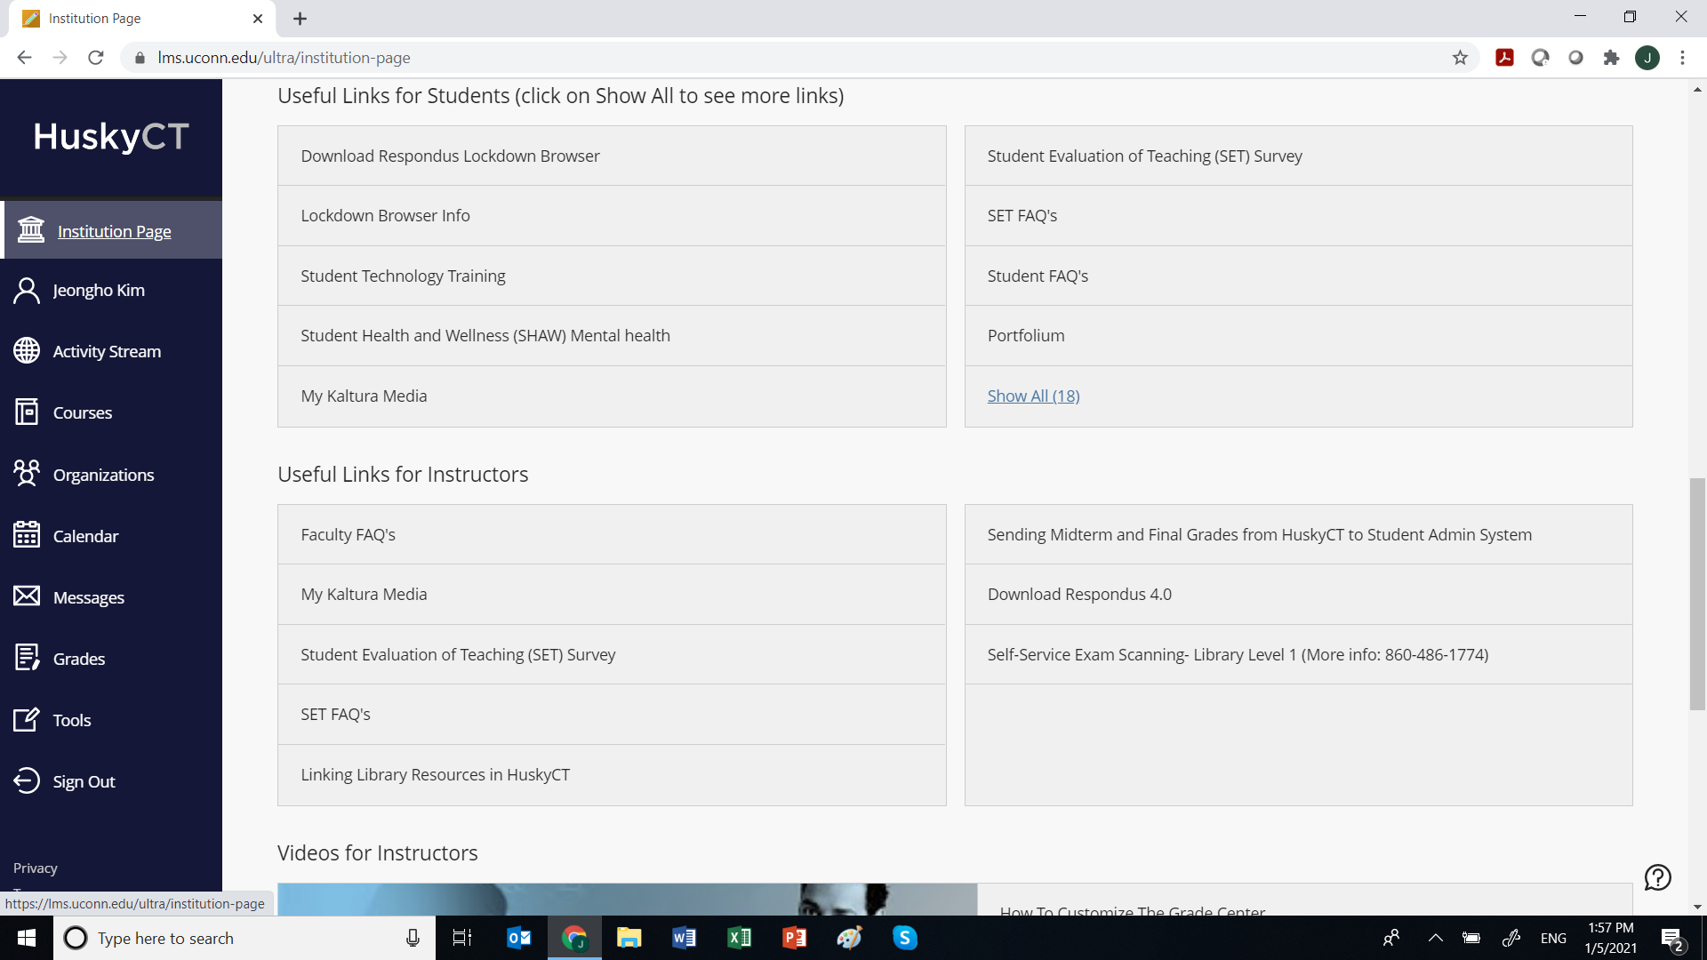
Step 2: Click Install Now
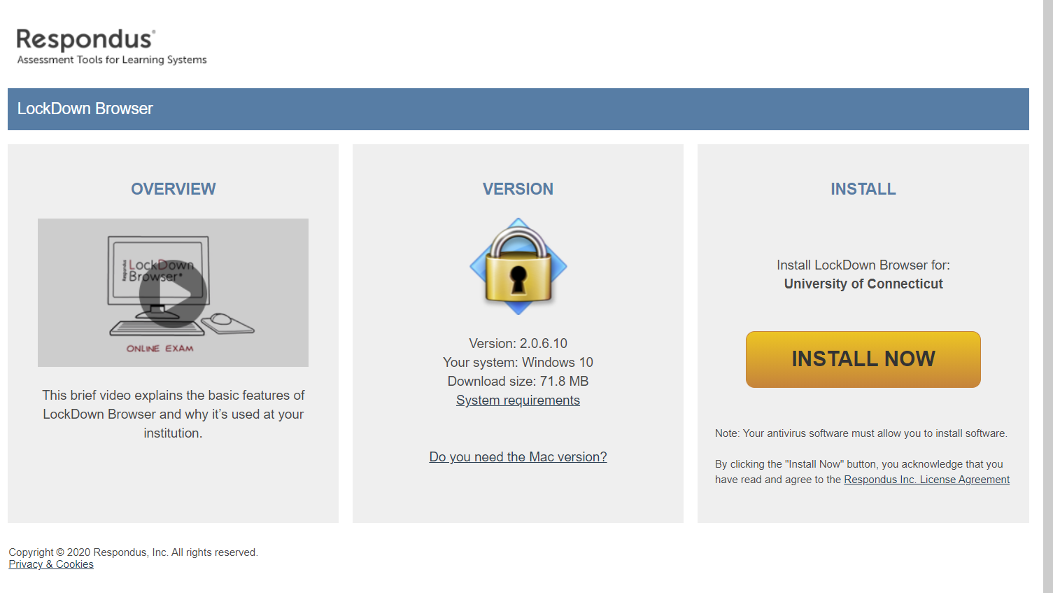
Step 3: Search for the installed software and Double click it
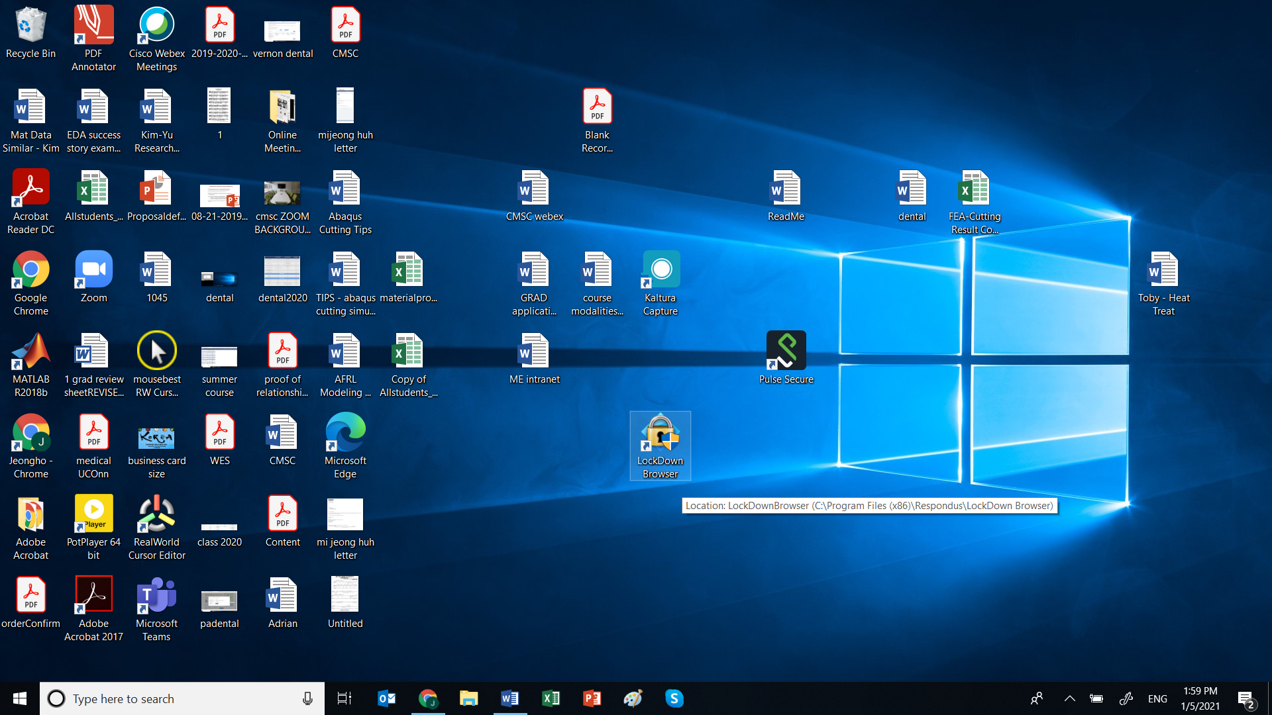

Step 4: You will need to go through a series of identification process below to begin the exam.
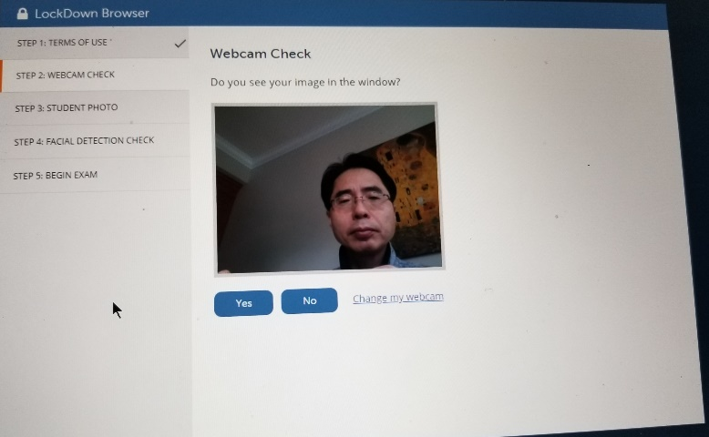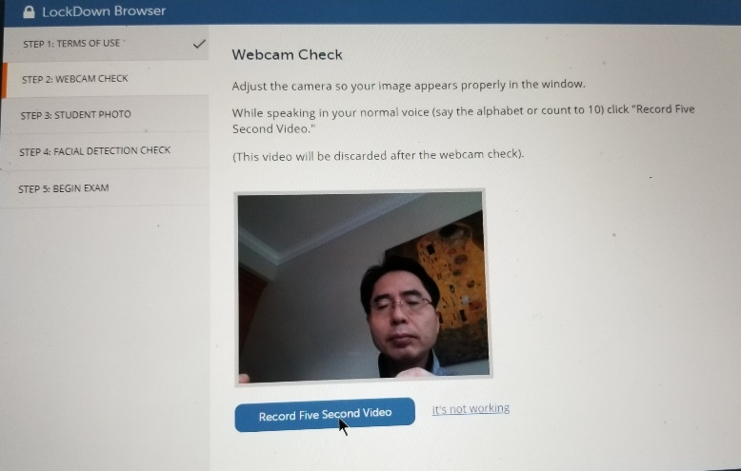

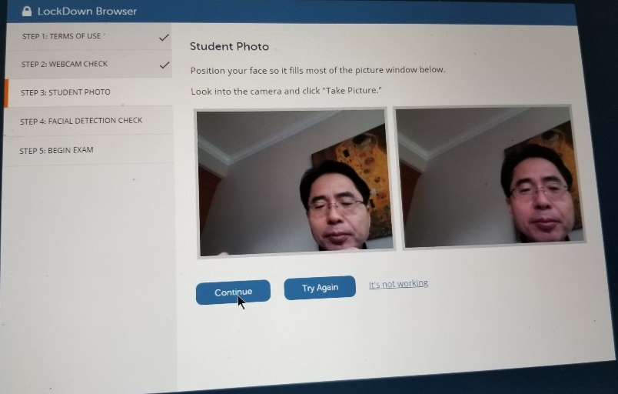
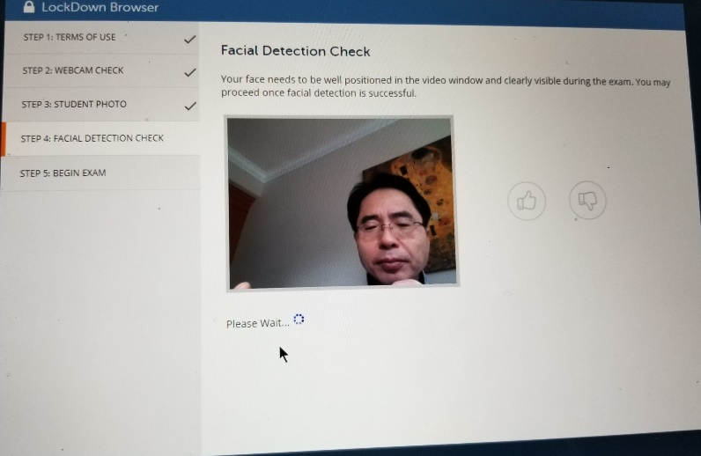
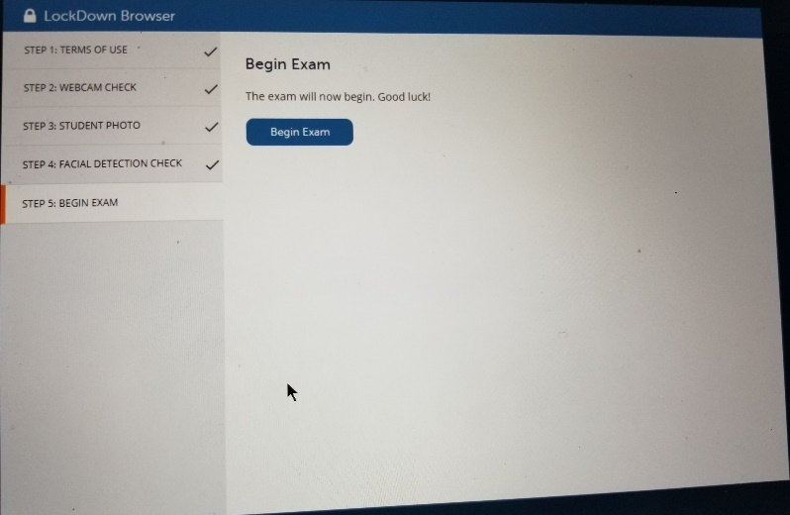

THE END

