Please follow steps below:
- Log in to the computer with your username and password.
- Open your presentation file.
  - If you have a PowerPoint file, you can draw on your slides if you choose the slide show (full presentation mode).
  - You can use OneNote if you would like to show a solution to a problem. You can insert problem statements, graphs, tables (or other required documents) in OneNote in advance.
- Make sure your file is displayed on the Tablet (left monitor).
- To record a video for your class, go to:
https://kaltura.uconn.edu/
Login from top right corner (under Guest).
- Click on +Add New on the top ribbon and choose Kaltura Capture.
- You will see this window:
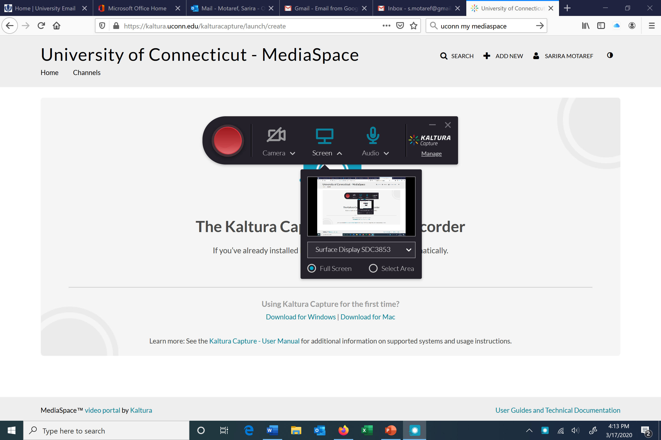
- If the camera sign is crossed (the same is picture above), your face will not be recorded along the video.
- If you choose to capture both screen and your face, then click on camera and remove the cross.
- Push the record button (solid red circle) to start your recording.
- To pause your recording, you can use the same ribbon and pause your video, stop, save, and upload.
- Make sure to record videos no longer than 10-15 minutes.
- The tablet pen is located on its top part. You can use it to write on your presentation or OneNote application.

